Lunar Lander

Introduction
This article centers around continuous episodic reinforcement learning tasks and state-action space generalizations. Given that it would be too computationally and memory expensive to represent every possible state-action enumeration of certain environments, it is appropriate to condense these paradigms in a generalized form. This form is more or less encapsulated in a linear function, or derivative of a linear function, such that a vectorized state input is mapped to an appropriate action-value response. The environemnt of interest for this article is the LunarLander-v2 problem.
The LunarLander-v2 problem is one in which an agent must land safely on the surface of the moon at a specific location designated by flags. With respect to the envrionment’s coordinate system, the landing pad is always located at (0,0). As notated directly from OpenAI:
“Reward for moving from the top of the screen to landing pad and zero speed is about 100..140 points. If lander moves away from landing pad it loses reward back. Episode finishes if the lander crashes or comes to rest, receiving additional -100 or +100 points. Each leg ground contact is +10. Firing main engine is -0.3 points each frame. Solved is 200 points. Landing outside landing pad is possible. Fuel is infinite, so an agent can learn to fly and then land on its first attempt. Four discrete actions available: do nothing, fire left orientation engine, fire main engine, fire right orientation engine.” - OpenAI
The state of the lander is represened by an 8-tuple s_{t} = (x, y, vx, vy, θ, vθ, leg L , leg R ) where (x,y) are the coordinate location of the lander at time t, (vx, vy) is the velocity of the lander in the x, y plane, (θ, vθ) is the angle and angular velocity of the lander respectively, and (leg L, leg R) is a binary state indicating whether or not the lunar lander’s legs are touching the ground; 0 = not touching, 1 = touching . This is deemed a continuous problem because there are no discrete states.
In model-based reinforcement learning algorithms, such as Dynamic Programming and basic Temporal learning, a model of the environment is utilized as a control system to select actions that produce a policy that maximizes expected rewards. Model in this context is not the same type of “model” that we speak of in traditional supervised learning; e.g. a trained random forest model. Instead, a model as referred to in model-based RL is one in which state transition probabilities is known. To know these transition probabilities implies full knowledge of the environment. The lander can enact four different actions; do nothing, fire the left engine, fire the main engine, or fire the right engine. Between the seemingly infinite permutations of the state representation and the 4 actions available to take, solving this problem as a model-based control problem is simply not feasible.
Instead, we solve this problem using function approximation. More concretely, this is an exploration and analysis to the model free solution of the Continuous Lunar Lander problem as presented in the OpenAI Gym environment via generalizations with Deep Q Networks (DQN).
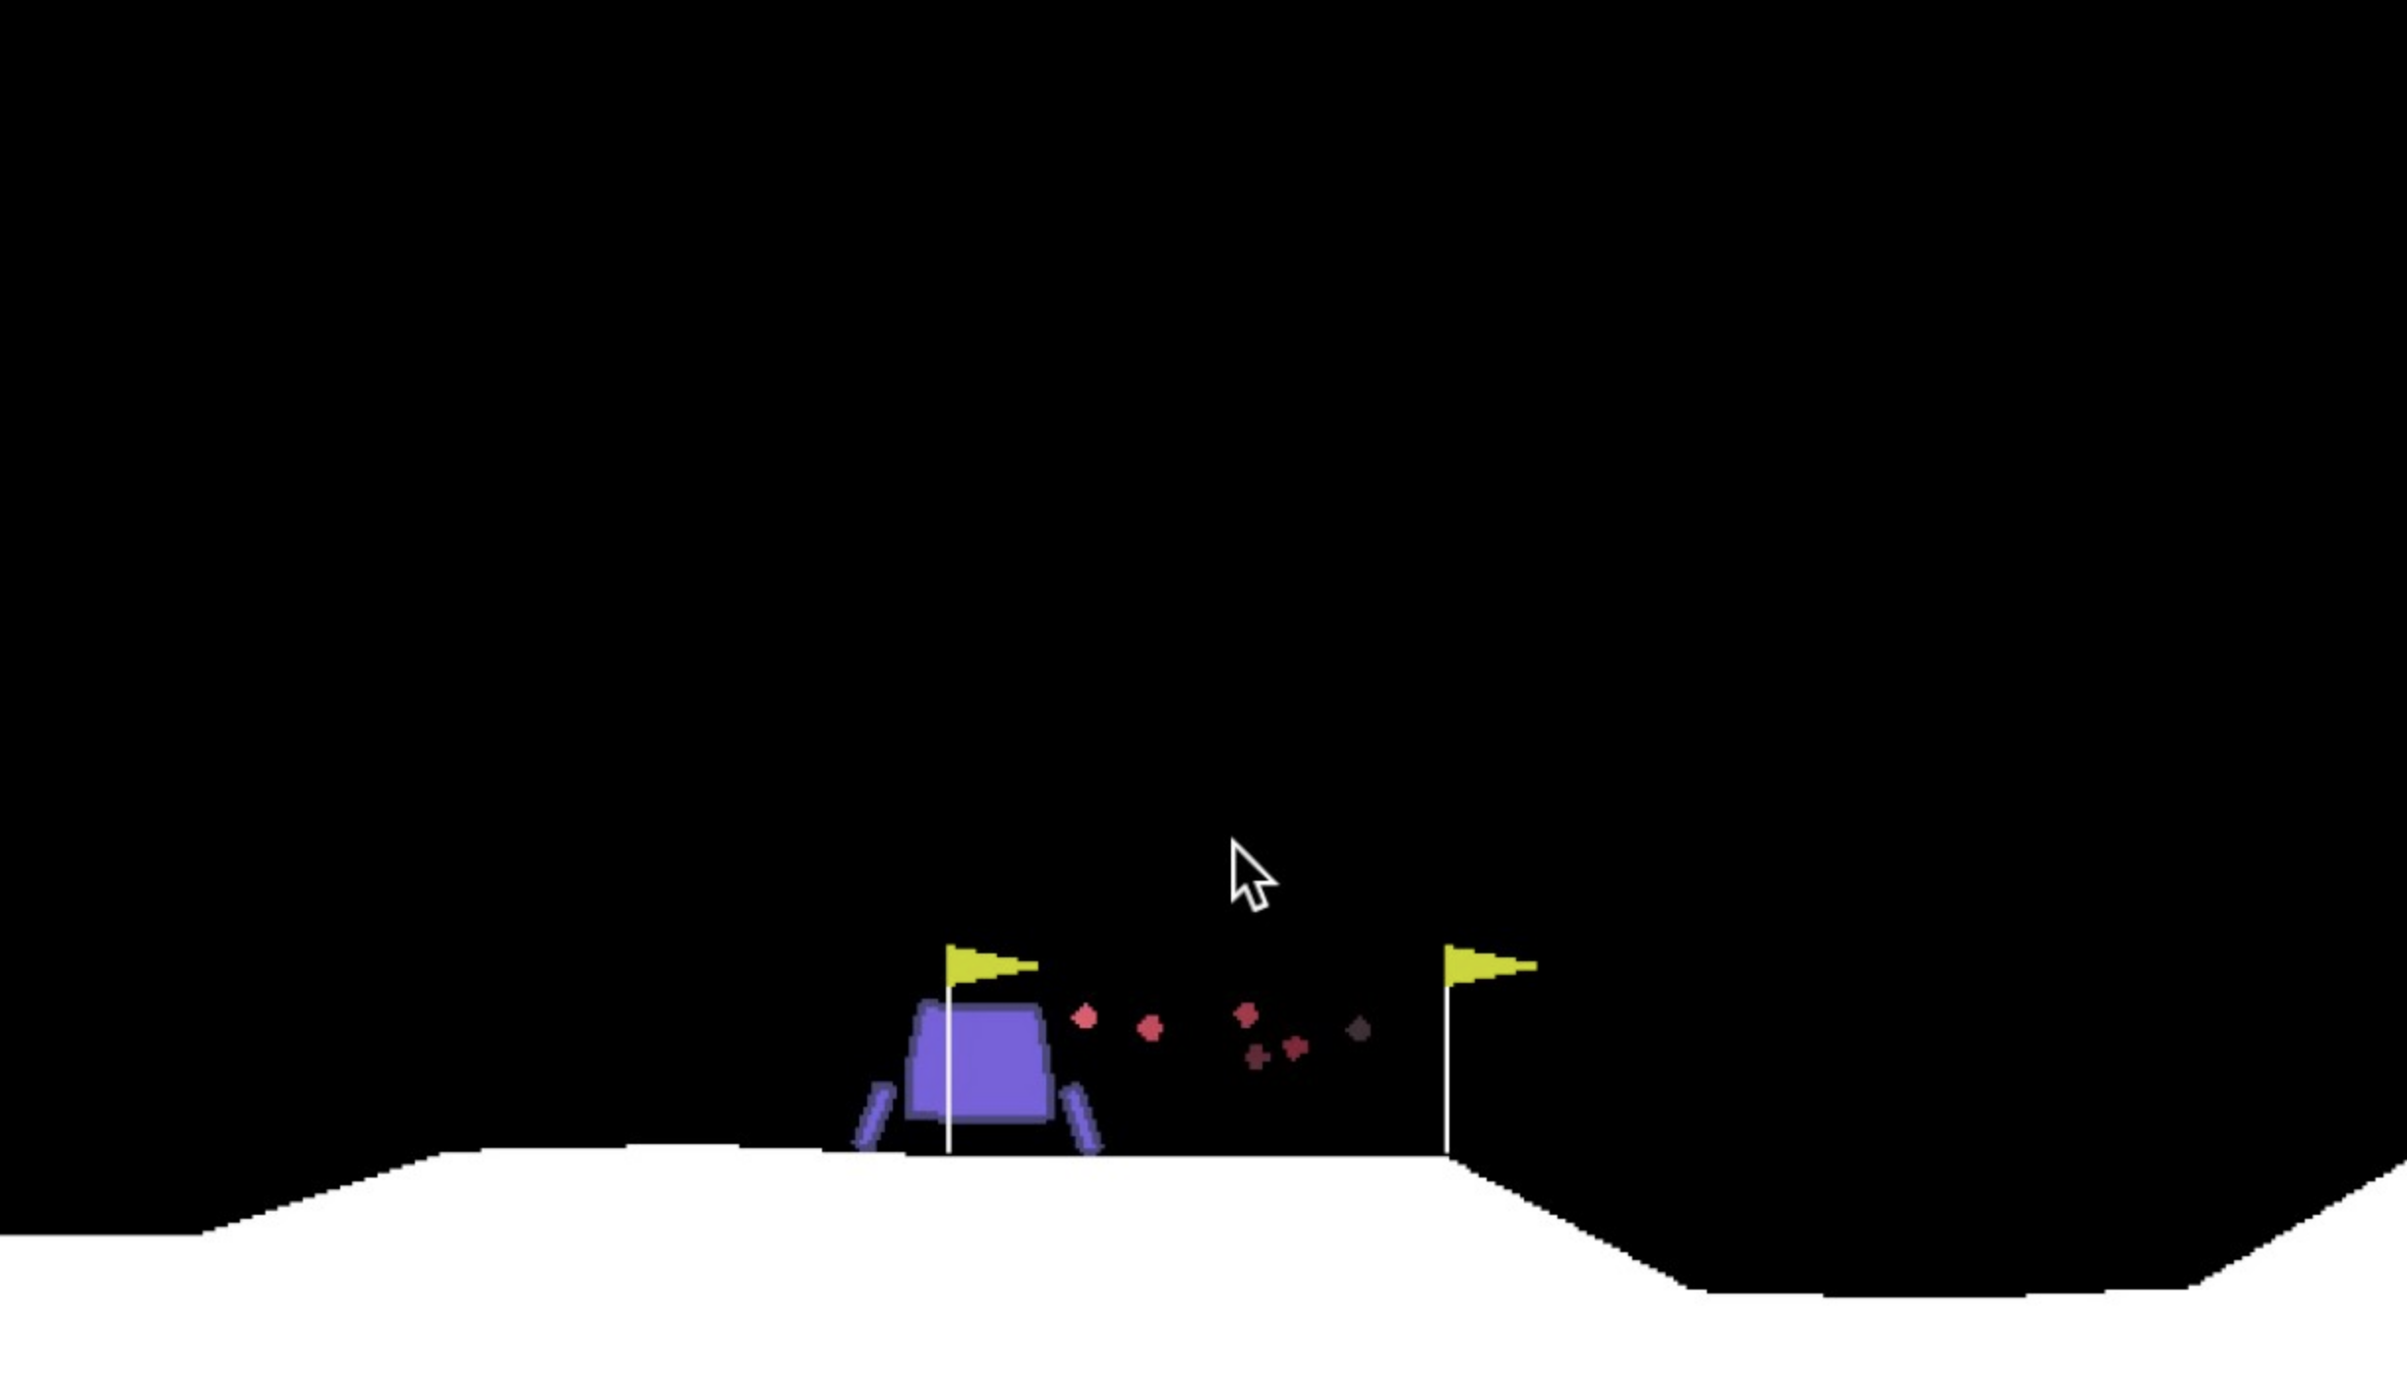
- Vanilla DQN
We will briefly explain the architecture of the solution model. Note that it is beyond scope of this paper to explain the intricacies of neural networks. We simply make note of the components for continuity and reduction of ambiguity. Given that the
state space for the lander is a continuous one, a three layer neural network was trained to serve as the approximation function for the state-action Q values. This is in contrast to a simplistic discrete environment where simply a “look up” table is created consisting of state indices and action columns. In this lookup table, for a given state, the action which produces the highest expected future returns is chosen. As stated earlier, this type of lookup table is infeasible due to computational and memory constraints of the continuous lunar environment.
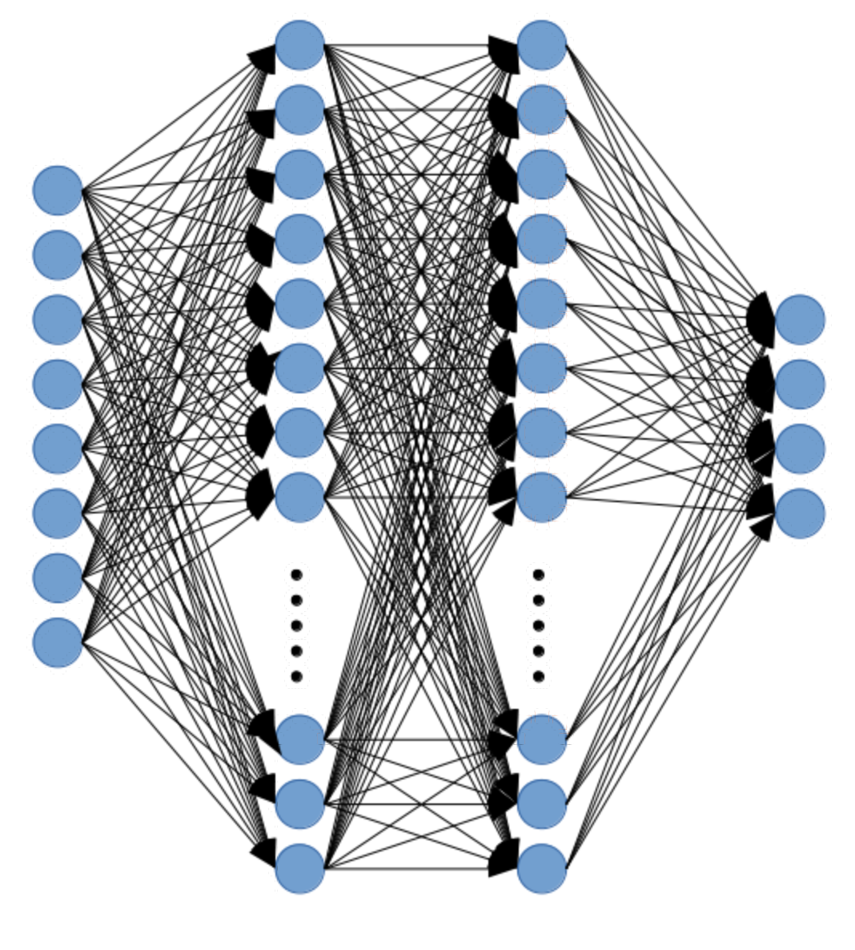

The experiment
Sutton’s experiment to highlight the efficacies of TD methods was a simple one in principle. He proposed a bounded random walk. Given seven different states [A, B, C, D, E, F, G], a walk always starts at state D. The only actions allowed during this walk is a one step transition either to the left or right. The action space is one of equal probability in that, there’s a 50% chance of going left or 50% chance of going right. The state you are in bares no influence on the action taken. A walk is deemed terminal whenever either state A or G has been reached. Transitions between states [B, C, D, E, F] yield zero reward. In fact no reward, either positive nor negative, is achieved unless state G has been reached. Reaching terminal state A nets 0 reward while state G nets a reward of 1. Figure 1 shows the exact depiction of the experiment as presented in Sutton’s paper.
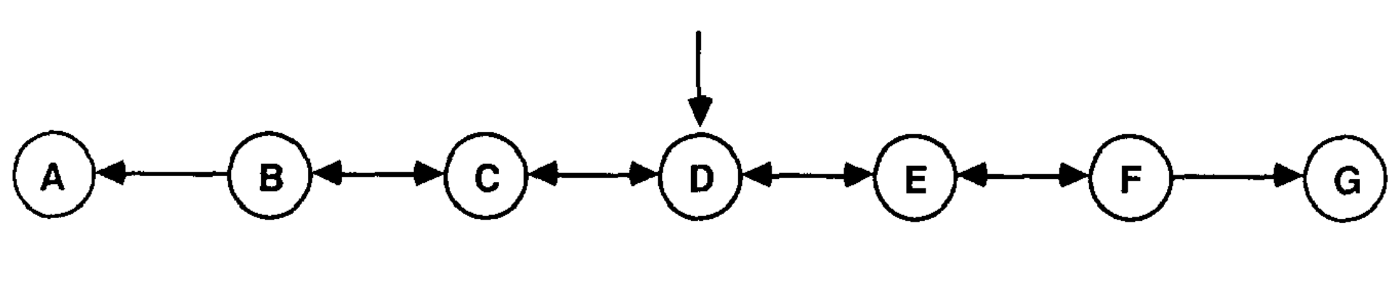Figure 1: Original depiction of the Markov process as designed by Sutton from his paper "Learning to Predict by the Methods of Temporal Differences"
Given the basis of this random walk experiment, we seek to find the value of each state. Value as used here, is a relative term with respect to the two aforementioned prediction algorithms. Although, both allude to the same thing, the context in which it is used differs. In supervised learning, the value of state is simply the probability of ending up in state G for any given state (or 1-probability for state A). An input state X_{B}, X_{C}, X_{D}, X_{E}, X_{F} is mapped directly to a prediction P_{t}. This prediction is the measure of “value”. Meanwhile, TD methods correlate value with “how good is it to be in a particular state”. It is an estimate of expected future reward given the current state. Continuing on, the use of the term weights or values is one in the same and will be used interchangeably.
From this scenario, two experiments were conducted. The first experiment centering around the proof of TD methods performing better than supervised learning in a dynamic environment. The second experiment seeks to highlight the underperformance of supervised learning over several permutations of learning rate and prediction methods. In either case, data ingestion during training remained the same.
Data is randomly generated in the form of 100 training sets. Each set contains 10 sequences of walks. There were no restrictions in place dictating how long a walk could be. Therefore, each training set contained walks of random variable length. For both experiments, all 1000 sequences were used during training. The difference in implementation between the experiments came with respect to weight updates and convergence objectives. Experiment one seeks full convergence while weight vectors are updated only after seeing all training data. Experiment two presents all data only once while updating weight vectors after seeing one complete sequence. Each experiment will be outlined with greater detail in subsequent sections
Identify applicable funding agency here. If none, delete this text box.

Experiment setup and implementation
The environment utilized for the experiments was Python version 3.7.5 running on Linux Ubuntu 18.04 LTS kernel. The first initiative was the implementation of a Random Walk Data Generator. Using the numpy library version 1.17.2, a class was built that would generate data sets at a user defined amount. Each dataset would contain variable number of sequences, again as defined by a user. Given that Sutton specifically outlined using 100 training sets containing 10 sequences, this ultimately was used. The structure of a single training set is as follows. An entire sequence of a random walk is contained in a Python namedtuple “Walk” which contains two named attributes; Route and Reward.
Route, is the randomly generated walk, vectorized as a M x 7 numpy array. M being the number of transitions taken during the walk. Each row is a unit vector of 6 zeros and a single 1, representative of the current state. Starting from state D, a number is randomly sampled from a uniform distribution between zero and one [0,1] using numpy. If the number sampled is less than 0.5, the action of a left transition is applied and another unit vector is created representative of state C. The opposite is true for a number randomly drawn greater than or equal to 0.5. A unit vector would be created representing state E. This process continues until either state A or G is reached. An example walk of X_{D}, X_{C}, X_{D}, X_{E}, X_{F}, X_{G} is illustrated in Figure 2.
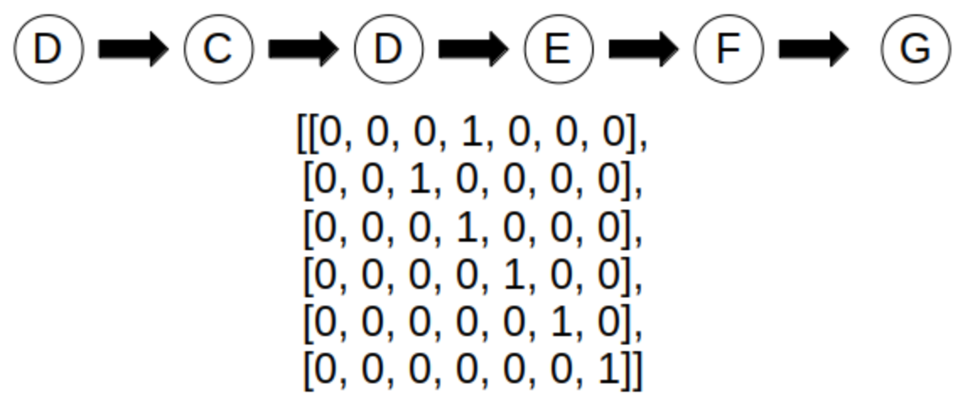Figure 2: Example of random walk that transitions across multiple states and how it is represented in vector format. Index for each row in the array is noted as states A, B, C, D, E, F, G
The Reward attribute of the namedtuple is a single vector of length M – 1. It maintains the rewards received for each transition as randomly generated. This, trivially, is a vector of all zeros except in the instance of a walk ending in state G. The subsequent vector for the walk in Figure 2 would be [0, 0, 0, 0, 1]. This was done for ease of indexing during algorithm implementation.
The algorithms themselves were reproduced using Python 3.7.5 and Numpy as well. Instead of using the exact gradient updates as notated in Sutton’s paper, the “eligibility trace” algrithm was utilized. The pseudocode can be seen in Figure 3. The psuedcode is taken from Sutton’s book Reinforcement Learning. The only change to the pseudocode in actual implementation was the placement of the weight updates. His will be dicussed further in later sections.
A. Experiment I
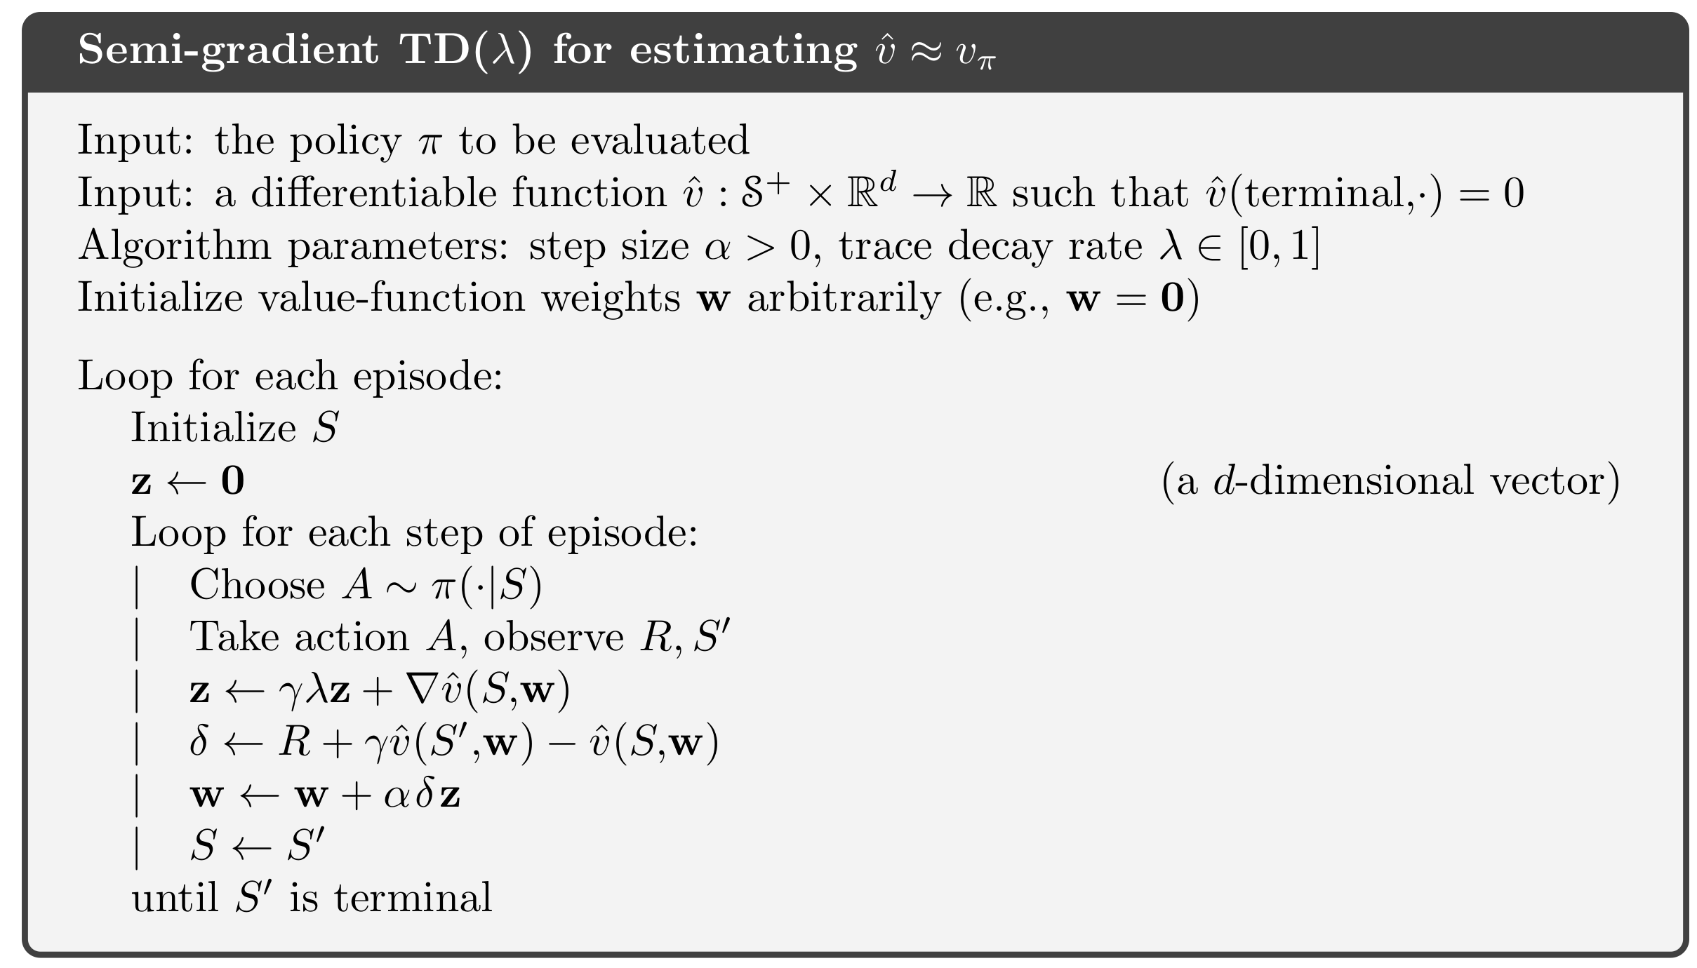Figure 3: Pseudo code from Barton & Sutton
The first experiment was centered around performance of TD methods versus supervised learning. Sutton dictated that during training, weights were accumulated until termination of the 10th walk in a set. The weights were then updated as given by (4). The sets were repeatedly iterated over until convergence. This simply means that all states were initialized to values of 0. For a given sequence, the value updates were stored for each transition. State values were then reset to 0 for the next sequence and the process repeated. After the 10th sequnce, the weight updates are performed and the updated values (weights) are the initial starting values for the next loop of the sequences. Upon convergence, the root mean squared error was calculated between the final state values and the ideal values as specified by sutton [1/6, 1/3, 1/2, 2/3, 5/6]
The aformentioned steps were performed for all 100 training sets so that the result was 100 different root mean squared errors. These RMSEs were then averaged to give the final error. These steps were repeated for varying levels of lambda between 0 and 1, inclusive. Sutton failed to specify two key aspects in his implementation. Equation (4) is dependent on lambda and learning rate, alpha. The paper only makes note of a “best alpha” value in the results, but doesn’t clarify what it was. Therefore, multiple permutations of lambda and learning rate alpha were utilized, in search of the reproduction of Sutton’s results. The alpha that best matched his results was found to be 0.01.
The second ambiguity was the convergence criteria. He only states in the implementation that each training set is repeated until convergence, but does not clarify what this was. The method used in our results was to maintain the previous iteration of all 10 sequences’ weight values as a separate variable. After performing the weight update step, the difference between the previous weights and the new weights was calculated. If this difference was less than or equal to 0.0001, then convergence was declared. The results from this experiment can be seen in Fig 2. The inset graph is the results from Sutton’s original experiment.
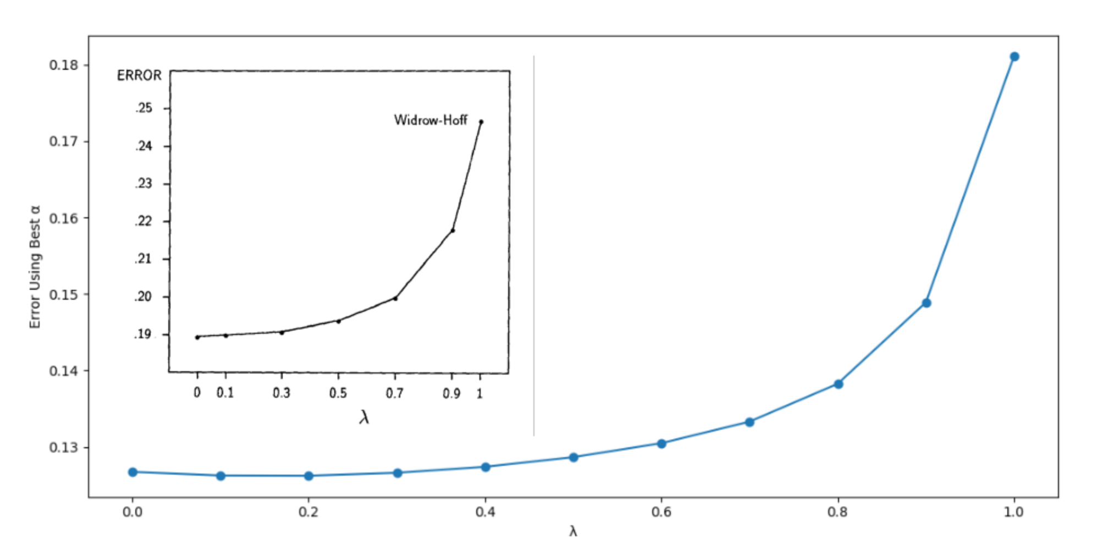Figure 4: Reproduction of Sutton's first experiment. The inset graph is Sutton's original results
It is clear from Figure 2 that TD(1), which is representative of supervised learning, doesn’t perform as well as all other methods of TD(). A better way to think of these results is to consider TD(1) not as supervised learning, but as Monte Carlo updates. When lambda is 1, no n-step averaging is taking place with respect to each update. The full return of all steps is accounted for with respect to the weight update procedure. This is no different than what is done with Monte Carlo methods.
For an episodic task, monte carlo accumulates the entire return value for each episode and then averages the results. One downside to this method is that an entire episode must terminate before anything can be learned, so learning is slower. Another problematic attribute of MC is that it is high variance. That is, it overfits whatever training data is presented to it from a sample. It doesn’t generalize very well to the true representation of the environment if those samples are skewed. If the random generator produces a training set that is very imbalanced to one terminal state over the other, then MC will tend more to the imbalanced side. It takes in no notion of connectivity or temporal information. For state D, if the random generator created a traing set of all sequences teminating in state A, except for one sequence, then the value of D would be far lower than the ideal value due to being averaged over more 0 rewards from state A.
TD methods, however, can learn during an episode. It is an averaging of all n-step returns to better represent a Maximum Likelihood estimate. The advantage of this method is clearly seen from the results; TD methods outperform supervised learning.
Note that the overall errors in our reproduction of Experiment 1 are less than those presented by Sutton. There is no “proven” explanation as to the differnece in magnitudes. Multiple training sets were randomly generated in order to find some combination of training sets that would produce such high errrors. We were unable to do so. We can only offer speculation to this, but a potential misinterpreation of the steps to reproduce Sutton’s experiment could have led us to lower errors. The opposite is likely as well, that Sutton performed some computational error during his experiment that went uncaught. The third thought on the matter comes down to the exact training set used. Sutton could have randomly generated a, typically, unlikely set of sequences that would cause such an increase in error from the norm.

Experiment 2
The next experiment was an attempt to highlight the inferior performance of supervised learning across a larger domain of the hyperparameter alpha. Experiment 2 is an exercise in gridsearch training. This means that multiple lambda values were tested across multiple alpha values. Only this time the values were intialized to 0.5, and each lambda method was not allowed to converge. Instead, each sequence for a given training set was seen only once. During the transitions of a single sequence, the weights were accumulated. Upon reaching a terminal state, the weights were updated with the accumulated weights, and these new weights served as the initial state values for the next sequence in the training set. After all 10 sequences had been seen, the RMSE was calculated using the same ideal values from Experiment 1. Again the end result is 100 RMSE values for the 100 training sets, that were then averaged to give the final error for a given lambda with a specific learning rate alpha. These steps were repeated for multiple values of alpha for each lambda value.
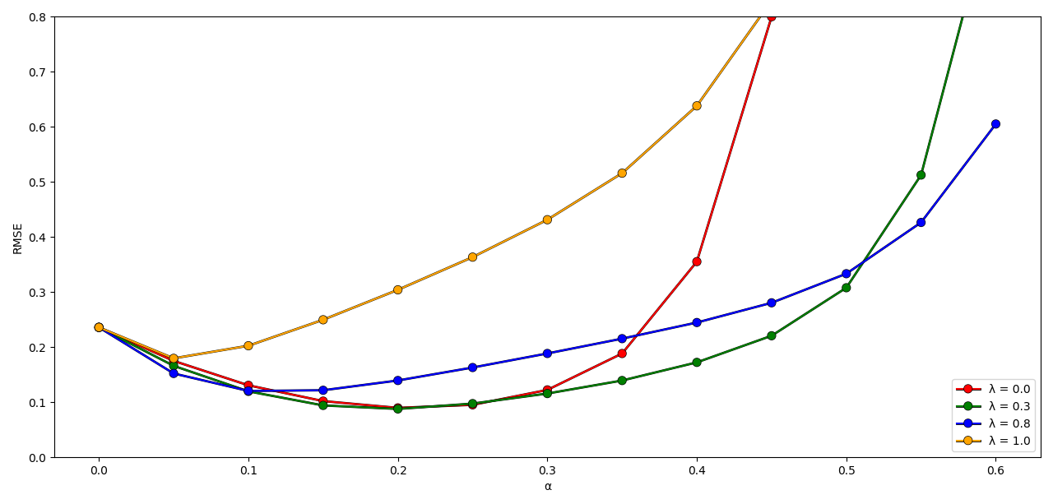Figure 5: Reproduction of Sutton's second experiment.
The results from experiment 2 can be seen in Fig 4. Note that the error for = 0 increases rapidly around = 0.4 and crosses over = 1 for our experiment. This is believed to be due to the length of the training sets generated. Sutton never clarified how long each sequence was in his original training set, nor did he specifiy if there was a maximum length restriction applied. However, it was discovered by others that limiting the maximum length of the sequences to a value around 20 transitions would produce the same results as Sutton’s original work seen in Figure 5. This intuitively makes sense however. Given there are only a total of 7 states, sequences with a large number of transtions obviously would visit the same states alot. This would cause an n-step average over a state, vast amount of times and dilute the derived value. We chose not to restrict sequence sizes in order to maintain pure randomness. We believe that by imposing a rule on the genration of states (maximum length), there comes a point in generation that the walks are no longer random and becomes deterministic.
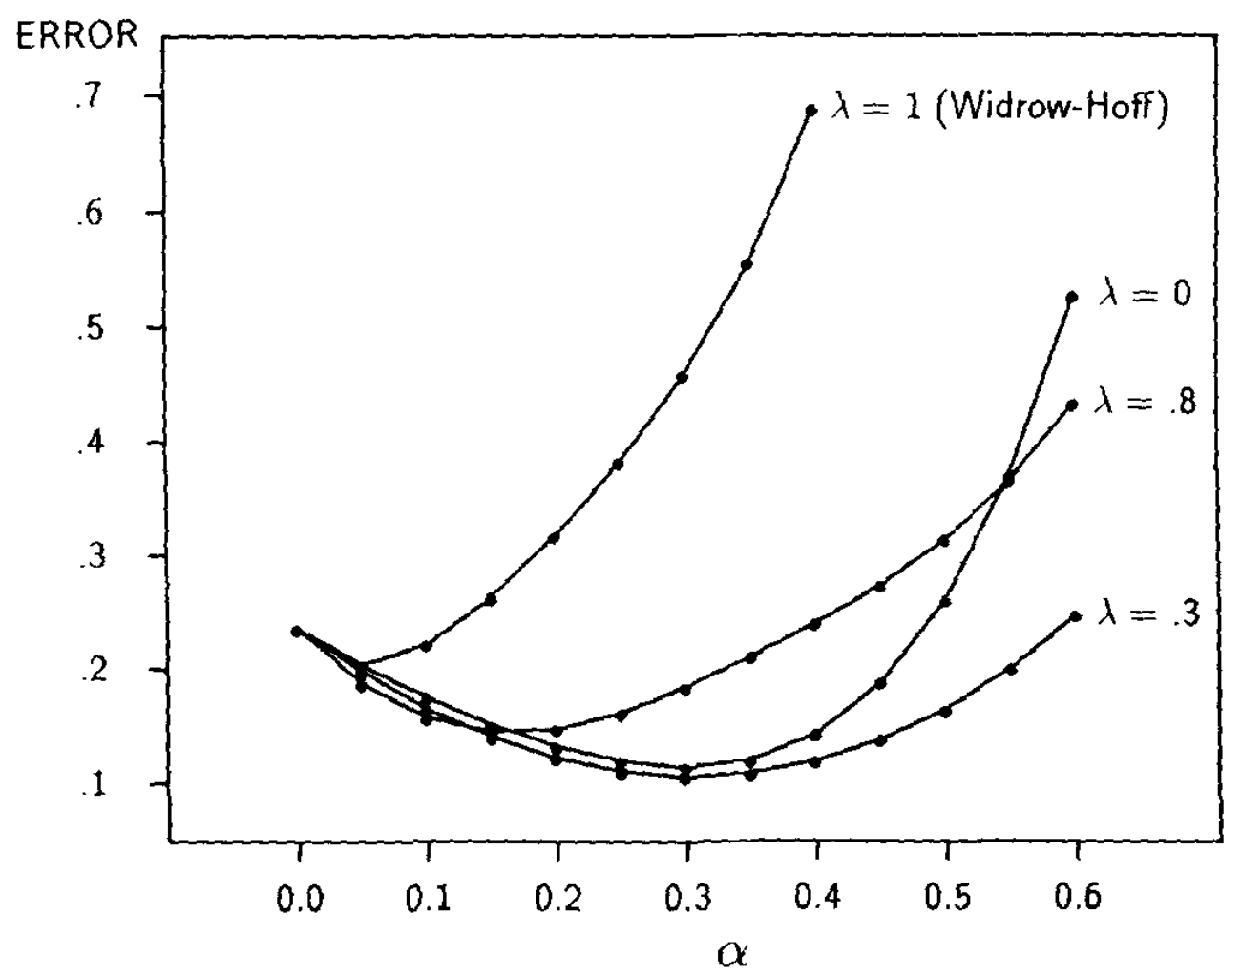Figure 6: Sutton's original results from Experiment 2

The general interpretation of the results is as one would expect in any learning situation. Given some learning rate, there is more or less, a sweet spot in which error is the lowest. As learning rate gets higher, the gradients tend to overshoot either a local or the global optimum and error increases. This is perfectly highlighted in Fig 4. All methods of lambda start to converge until a particular alpha is reached that causes optimization to diverge. In all cases however, each TD method less than 1 performed better than TD(1).
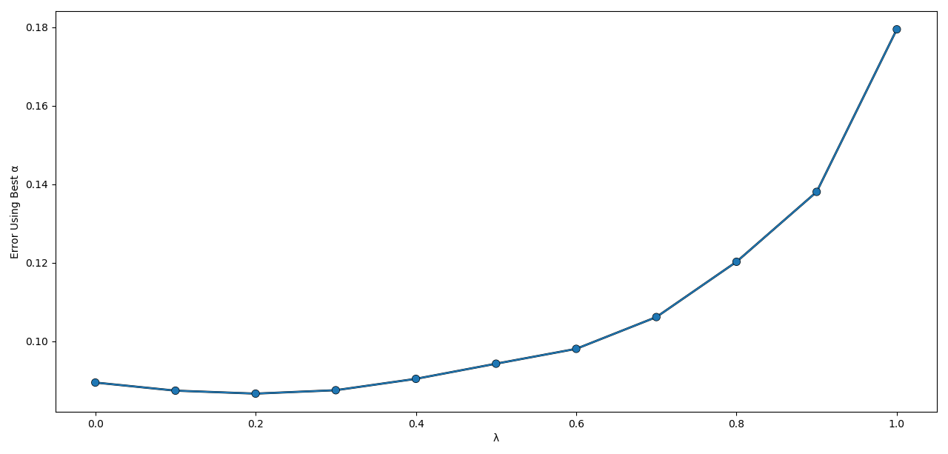Figure 7: Results from Experiment 2 that shows the alpha values for multiple values of lambda that produced the lowest error for that lambda value.
Finally, the best alpha value for several lambda values was extracted from experiment 2 and plotted. The results can be seen in Figure 6. Just as it was seen earlier from experiment 1, supervised learning fails to outperform all lambda values less than 1. The main thing to note here is that lambda of 0 is not the optimal method like it was in Figure 2 from the previous experiment. This is an effect of not allowing convergence of each training set. TD(0) is only a one step look ahead, so it takes multiple updates to the weights before the change at state F, for example, is realized at say, state B. Since each sequence was looped through once, not much information was backpropagated through the states.
One major event of misinterpretation of Sutton’s experiment 2, on our part, had to do with the weight update step. Sutton stated for Experiment 1 that no weights were updated until all 10 sequnences had been seen. With experiment 2, the weights were updated between sequences. Although the wording was clear that it was a backward view¹ implementation, we initially performed an exact online implementation. We were updating the weights inplace between individual transitions in a sequence, not between the sequences themselves. It was only after conferring with fellow students on the appropriate experimental steps that the error was discovered. Upon correcting the updating step, we were able to produce the same general results as Sutton. Surprisingly enough, this one change in placement of the updates greatly changed the results of the experiment. The overall proof these experiments were trying to convey still held true however, that supervised learning methods are inferior in multi-step dynamic environments to TD methods.

References

